No. of Pages | 6
No. of Questions | 7

Department of Computer Science and Engineering
FINAL EXAMINATION SUMMER 2012

CSE490/EEE453: LAN Switching and WAN Technologies
Total Marks:75 Time Allowed: 3 Hours

- Answer any FIVE (5) questions out of the given SEVEN(7) questions.
- Figure in bracket [] next to each question indicates marks for that question.

Question No. 1

- What are Static and Dynamic vlans? [3 marks]
- Why do network administrators recommend changing the management vlan from VLAN1 to another vlan number? What kind of traffic flows through the management vlan, give specific examples? [3 marks]
- Does a switch need an IP address? Why or why not? [3 marks]
- List three common problems associated with vlans. Explain one, (what is the problem and how do we solve it). [4 marks]
- What is the purpose of the command “ip http server” shown in the output shown in figure no.1? [3 marks]
!
interface Vlan1
ip address 192.168.24.2 255.255.255.0
no ip route-cache
!
ip http server
!
!
end

Figure No. 1

Question No. 2

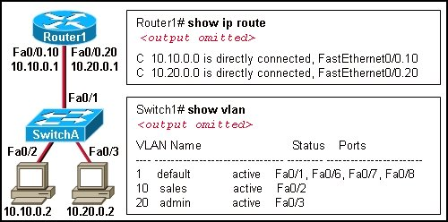
Figure No. 2

- Refer to the outputs shown in the above figure no. 2, the two hosts has no connectivity, why? [2 marks]
- Referring to the same network shown in figure no. 2, suppose you must create a new vlan 30 called “guests” in SwitchA. Port Fa0/4 must be assigned to vlan 30 and a PC with the IP address 10.30.0.2 is connected to that port. For all PCs to have connectivity, what commands are required at the Router1 and SwitchA? [4 marks]
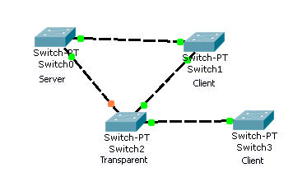
Figure No. 3
- Refer to the figure no. 3 above; the network administrator has just added VLAN 20 in Switch0 and VLAN 60 in Switch 2. What actions will occur after that? [4 marks]

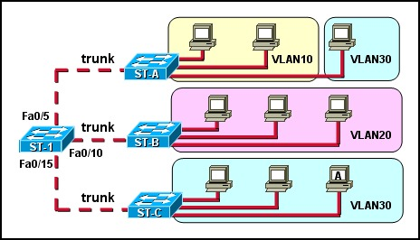
Figure No. 4

- Refer to the exhibit shown in figure no. 4. How will switch ST-1 handle Layer 2 broadcast traffic originating from host A on switch ST-C? [3 marks]
- Which configuration changes will increment the configuration revision number on the VTP server? [2 marks]

Question No. 3
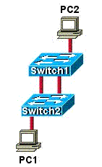
Figure No. 5

- Refer to the figure no. 5 above. PC1 sends a broadcast frame to PC2. STP is not enabled, what are the probable problems that can occur? [3 marks]
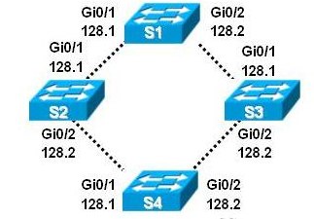
Figure No. 6
- Referring to the figure no. 6 above, what does the value 128.1 and 128.2 refer to? When is it used? [4 marks]
- If the default priority of a switch is 32768, why is the priority shown as 32769? When is this priority value used and how? [4 marks]
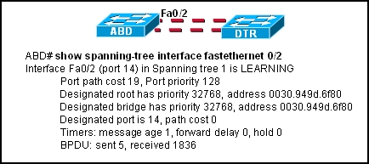
Figure No. 7

- Refer to the exhibit shown in figure no.7. What does “LEARNING” mean as it relates to the Spanning Tree Protocol? [2 marks]
- Which STP port states are equivalent to the RSTP discarding port state? [2 marks]

Question No. 4

- Differentiate between named ACL and normal ACLs. [3 marks]
- What is the purpose of Time based ACLs? [3 marks]
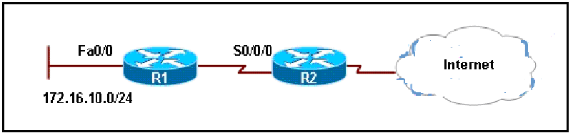
Figure No. 8

- Refer to the figure no. 8 above, configure a named ACL called SAFE_WEB so that all hosts from the inside can access any web content but web responses from the outside are only allowed for established connections initiated from the inside. DON’T forget to place the ACL. All other traffic is also allowed. [5 marks]
- When a network administrator has to block all traffic from inside going outside, which ACL is better standard or extended? What about traffic coming from outside? [4 marks]

Question No. 5
<output omitted>
ip dhcp excluded-address 192.168.1.1 192.168.1.5

ip dhcp pool 192Network
default-router 192.168.1.1
dns-server 192.168.1.10
!
interface FastEthernet 0/0
ip address 192.168.1.1 255.255.255.128
duplex auto
speed auto
!
<output omitted>

Figure No. 9

- Refer to router configuration output shown in figure no. 9. Hosts connected to this router are having problems with DHCP. Find the problem/s? [4 marks]
- What will be the result and purpose of adding the command ip dhcp excluded-address 192.168.24.1 192.168.24.5 to the configuration of a local router that has been configured as a DHCP server? [3 marks]
- A company has two subnetworks for its two branches, 192.168.10.0/24 and 192.168.20.0/24. Write the commands, which are necessary for a router to dynamically translate any address of the company to a NAT pool of 212.2.2.24/29. [5 marks]

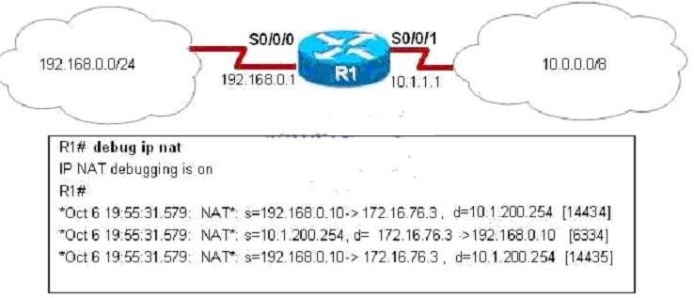
Figure No. 10

- The above output shown in figure no. 10, shows the NAT translations being done by the router instantaneously. Write the NAT command that would produce this output. [3 marks]

Question No. 6

- PPP is better than HDLC, why? [2 marks]
- What is the purpose of the “Quality Magic Number”? [2 marks]

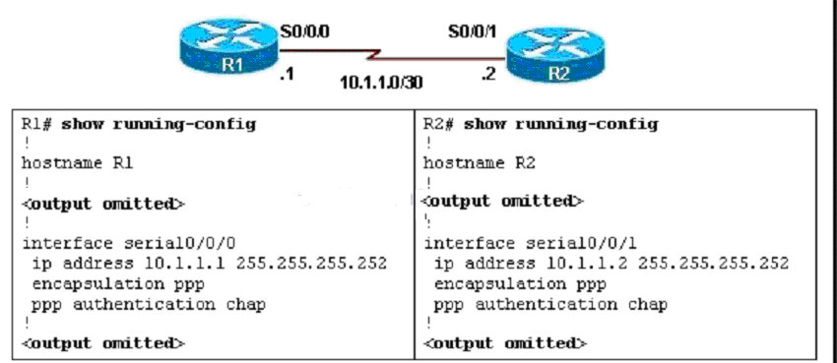
Figure No. 11

- Refer to the output shown in figure no. 11, a network administrator has been asked to configure PPP with CHAP authentication over the serial link between routers R1 and R2. What additional configuration should be included on both routers to complete the task? [3 marks]
- What are the functions of LCP? How do we know LCP has finished its tasks? [4 marks]
- Why is PAP called a Two Way Handshake process, explain? What is the disadvantage of using PAP? [4 marks]

Question No. 7

- The output shown in figure no.12 below shows a frame relay connection. For the frame relay to work more commands are required at HQ. What are they and why? [4 marks]

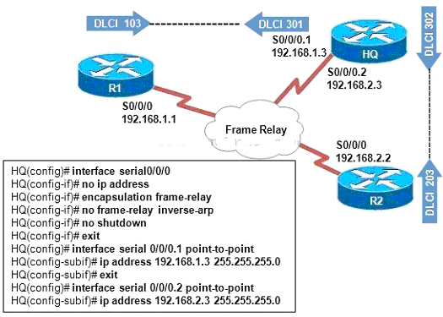
Figure No. 12

- What are LMI used for? Name the available standards. [4 marks]
- What kind of Circuit are being used in Frame Relay? [2 marks]

- A company has a CIR of 32 Kbps. But the access line is 64 kbps. So the company can send upto 64 kbps at times. Now while it was sending at 64 kbps, congestion occurs at the network. What do the frame relay switches do when this happens? [5 marks]

THE END

